Production of Southern California Campaign GPS Crustal Motion Solution and Time Series
Zheng-Kang Shen
UCLA
April 2017

As part of the effort to produce the SCEC Community Geodetic Model (CGM), we have worked on the production of the southern California campaign GPS crustal motion model (CMM) solution and time series. This report describes the CMM solution and time series and the procedures we have taken to produce the products.

- GPS data

We have collected all the precise campaign GPS data collected in southern California from 1986 to 2014 that were accessible to us. These data were primarily downloaded from the SCEC, UNAVCO, and USGS GPS data archives, with particular helps from Duncan Agnew of UCSD, Fran Boler of UNAVCO, and Jessica Murray of USGS. The data were collected primarily by researchers from the geodetic research community over the last three decades. Most of the campaign data surveyed prior to 2004 have been used for the production of the SCEC CMM version 4.0, and sources of the data were documented in the CMM4 paper of Shen et al. (2011) and would not be cited again here. More campaign GPS data were collected since 2004 and have been included in this solution, particularly the data collected from (a) the San Bernardino Mountains region by a group of researchers from the Cal. State Univ. of San Bernardino (Sally McGill), Arizona State Univ. (Josh Spinler, Rich Bennett), and UC Riverside (Gareth Funning); (b) the San Jacinto fault region by Yuri Fialko and his group at UCSD; (c) postseismic campaign of the 2010 El Mayor-Cucapah earthquake by Javier Alejandro Gonzalez-Ortega and David Sandwell of UCSD; and (d) campaign surveys in various regions in southern California by Jerry Svarc of USGS. To assure quality of the solution we select the data to have at least 2 years of observation time span at a site. The spatial region for data selection is 30°-36.5°N, 114°-122°W. About 850 campaign sites are selected, and their locations and data survey time spans are shown in Fig. 1.
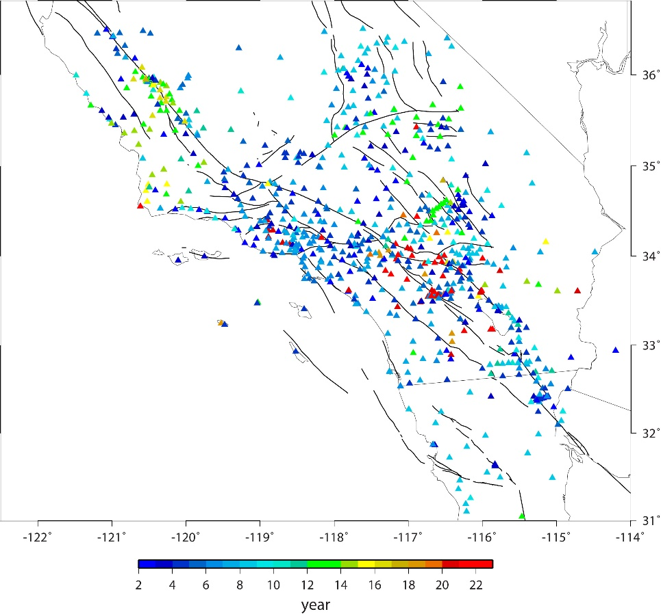
Figure 1. Campaign GPS sites and their observation time spans.

- GPS Data Processing

  - Daily GPS Data Processing

The daily campaign GPS data were processed using the GAMIT software version 10.50 (Herring et al., 2010). In each processing, data from regional and global tracking sites are also included along with the campaign data to establish the reference and assure solution quality. Prior to 1994 there was only a limited number of continuous GPS tracking sites in the world, and data from all of these tracking sites are included in one processing. After 1994, multiple solutions are run for each day, including (a) a regional solution including data from the campaign sites and 20 regional continuous sites in California and vicinity, (b) a regional solution including data from 50 continuous sites in north America, and (c) a global solution including 50 IGS continuous sites around the globe (Fig. 2). All the solutions adopt data with 0-24 UTC hour daily boundaries each day, except that for some days the daily boundaries are shifted up to 4 hours forward or backward to accommodate the across day boundary data epochs of campaign surveys.

For each solution the pseudo-range and carrier phase GPS data were inverted to solve for station positions, tropospheric delays, satellite orbits, and polar motion and ut1 parameters. Loosely constrained solutions are output, along with their full variance/covariance matrices. These daily solutions are combined using the GLOBK software (Herring et al., 2010), and the combined daily solutions are output again as loosely constrained with the full variance/covariance matrices.
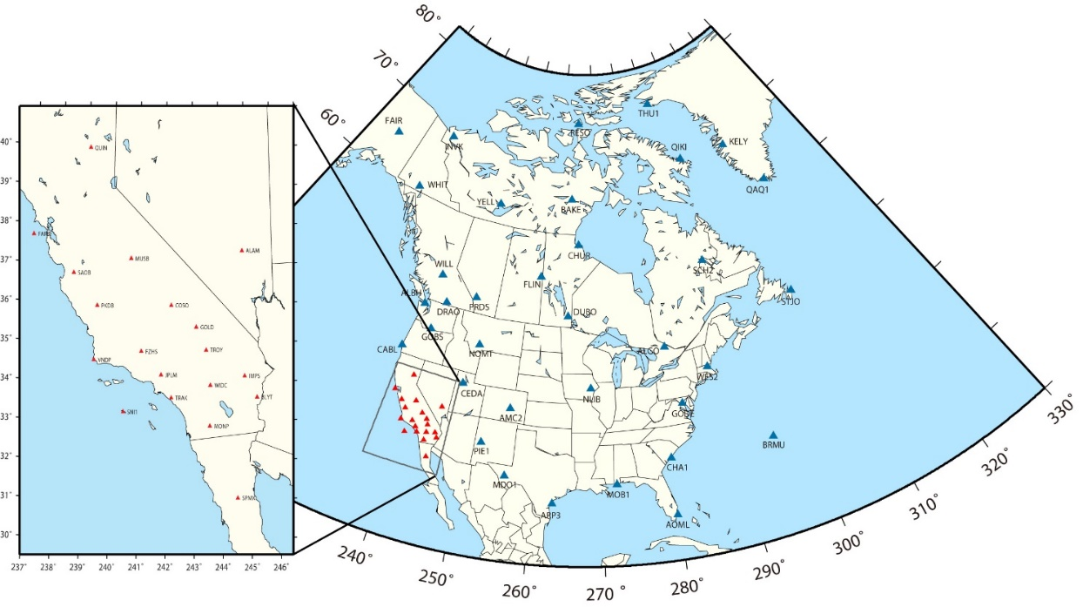
Figure. 2. North America tracking sites and California continuous sites selected as backbone sites to tie the solution with continuous GPS network solutions and to establish the North America reference frame.
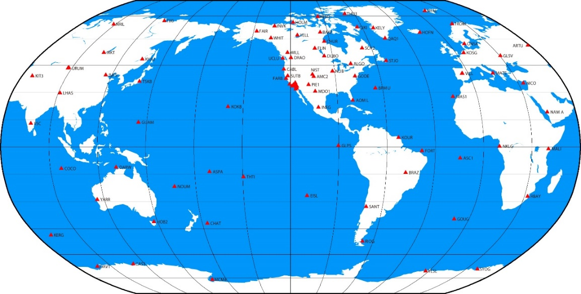
Figure 3. Global tracking sites selected to tie the solutions to the global reference frame.

  - Production of Crustal Motion Model

We aggregate the loosely constrained GPS daily solutions to produce the crustal motion model and station time series. Only the station positions, polar motion/ut1 parameters, and their variances/covariances from the solutions are used as pseudo data input. The QOCA software (http://gipsy.jps.nasa.gov/~qoca/) is used, and the crustal motion model is derived through a Kalman filter procedure, similar to what was done to produce the SCEC CMM4 solution (Shen et al., 2011).
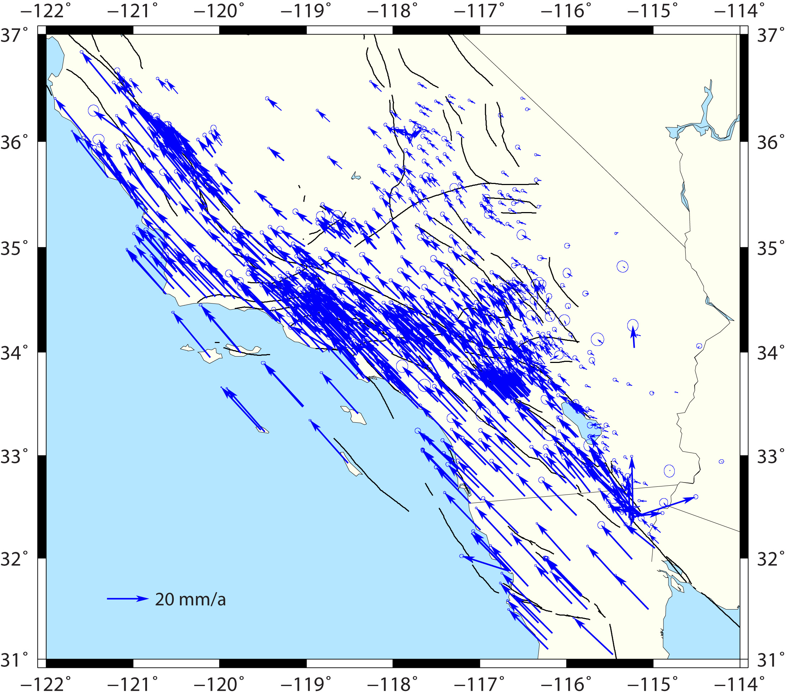
Figure 4. Campaign GPS velocity estimates with respect to North America plate. Error ellipses represent 95% confidence.

The GPS station position time series are modeled in the functional form:
D(t-t₀) = D₀ + V(t-t₀) + Σ_{k} Q_{k} H(t-t_{k}) +Σ_{k} P_{k} H(t-t_{k}) Log (1+(t-t_{k})/T)
where t₀ is the reference time epoch, D₀ the initial position, V the station velocity, Q_{k} the coseismic jump during the k-th earthquake, t_{k} the k-th earthquake occurrence time, H the Heaviside function, P_{k} the postseismic displacement amplitude of the k-th earthquake, and T the postseismic relaxation time constant. Q_{k} and P_{k} are zero if the site is distant from the quake epicenter, non-zero if a priori forward modeling of the coseismic displacement is greater than a threshold value. Table 1 lists the strong earthquakes whose coseismic and postseismic displacements are modeled.
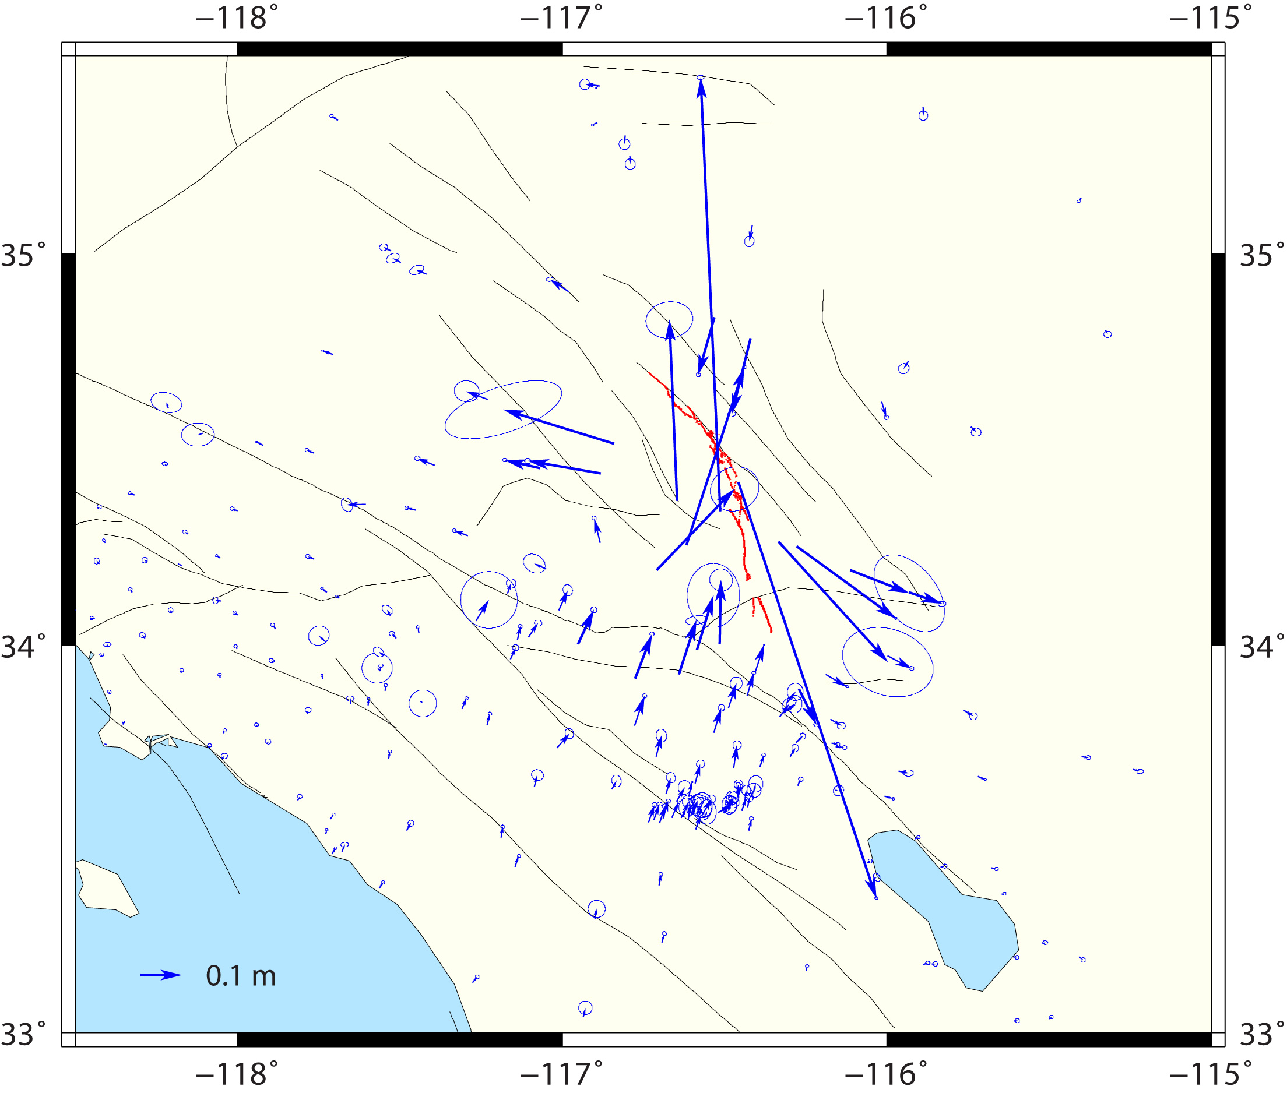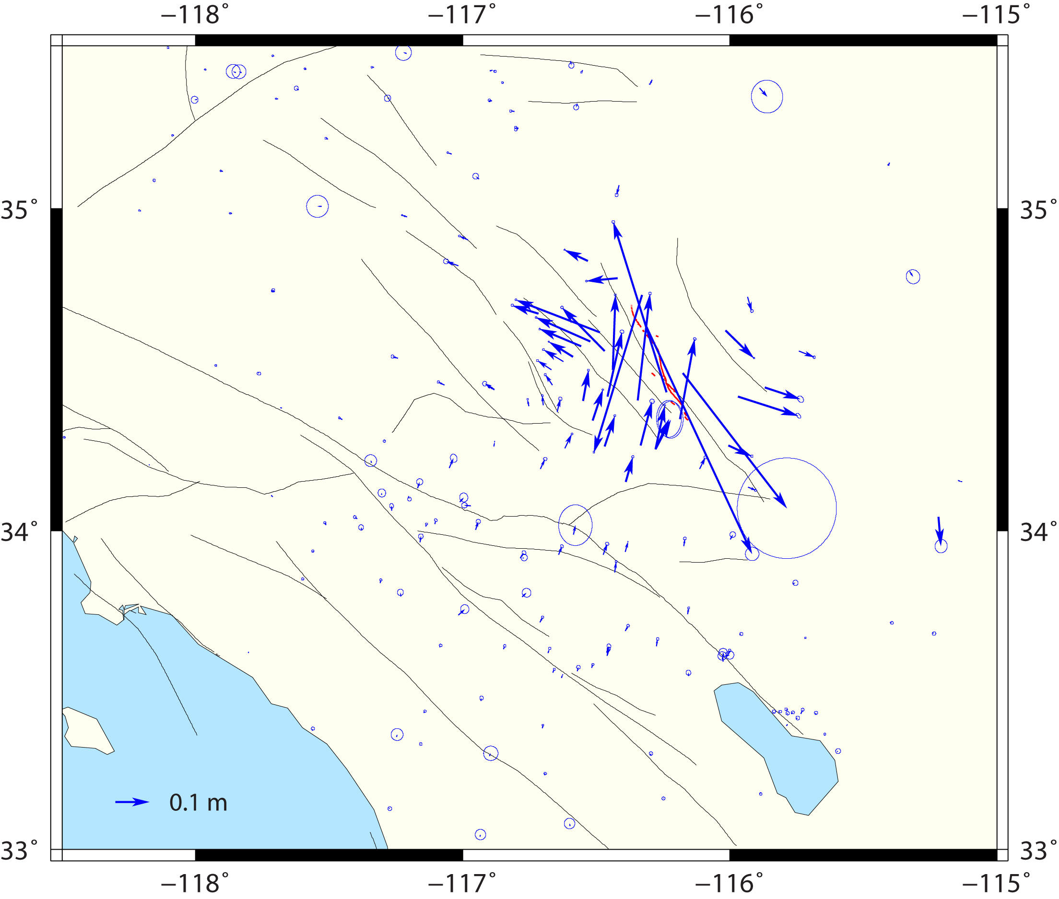
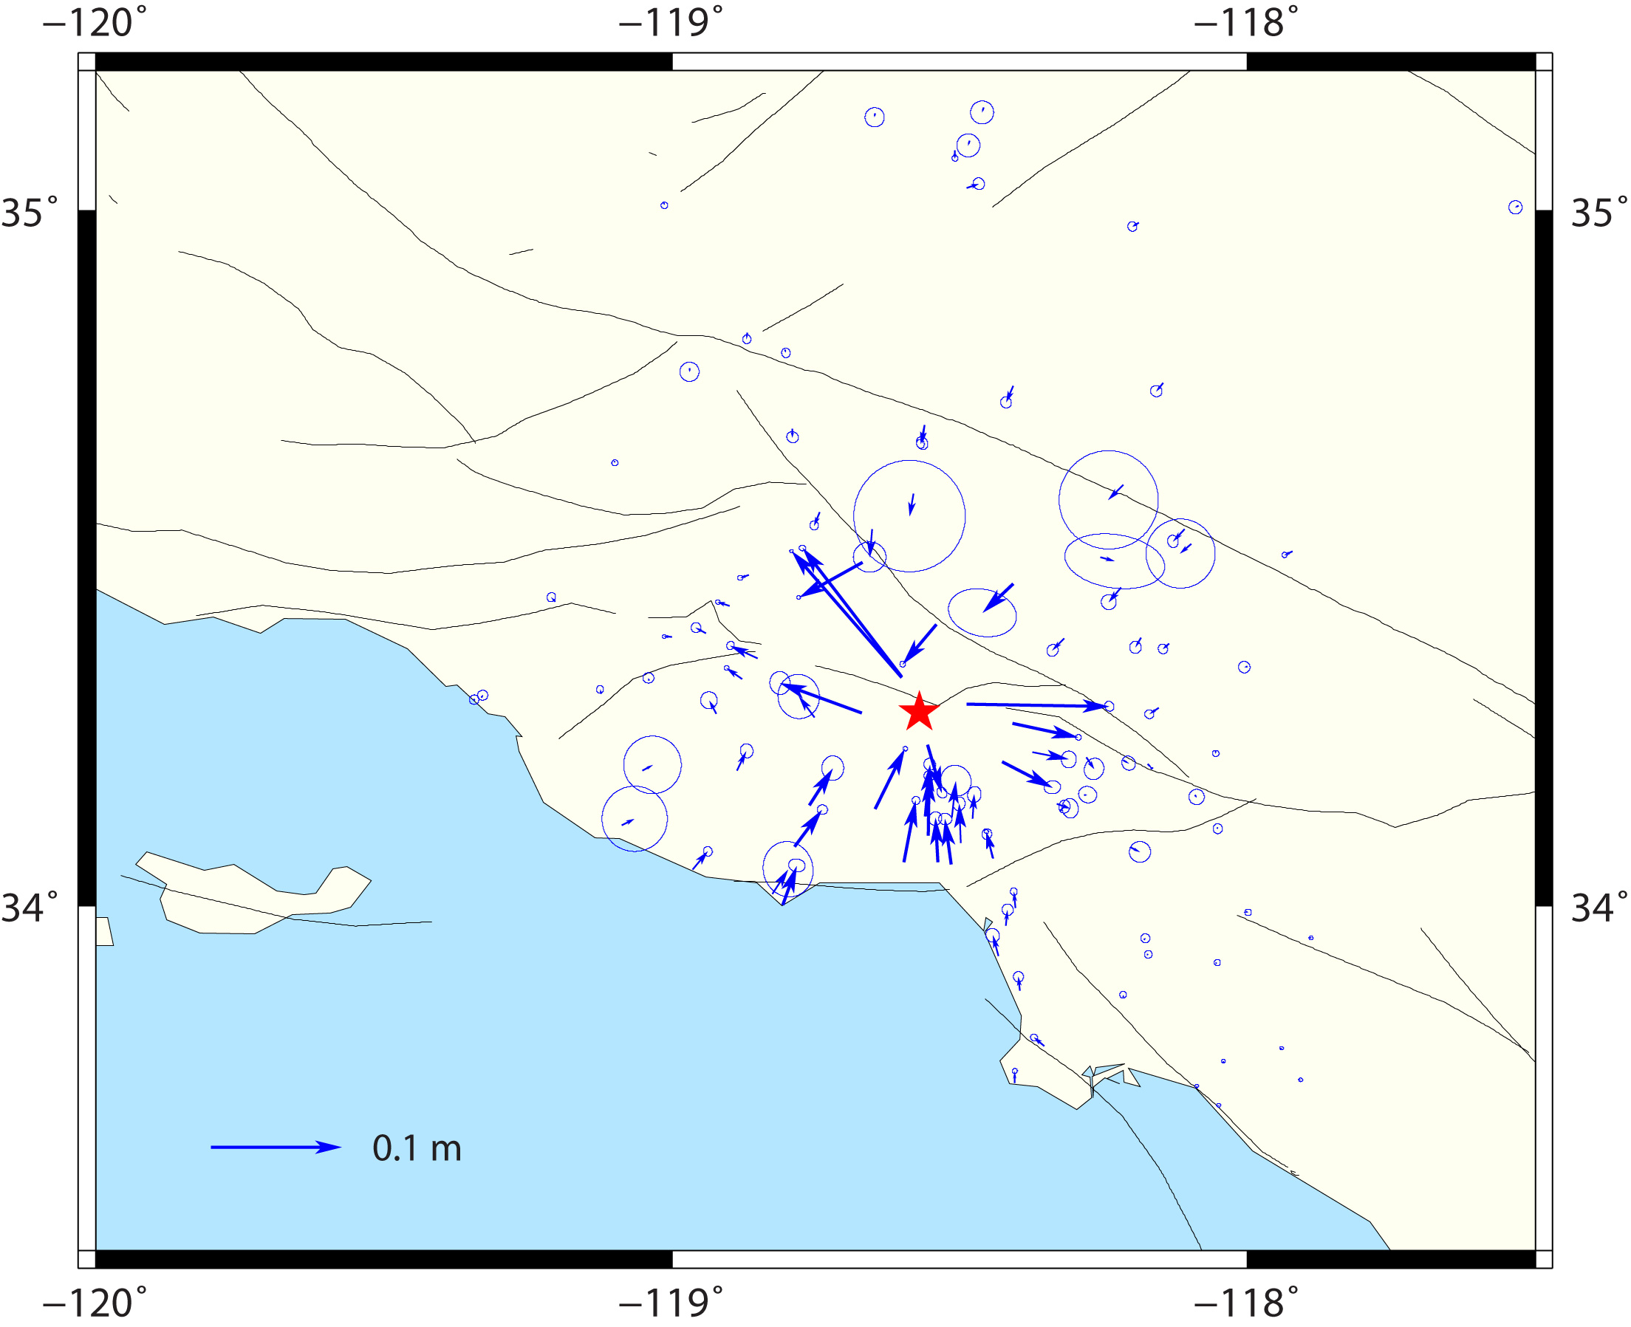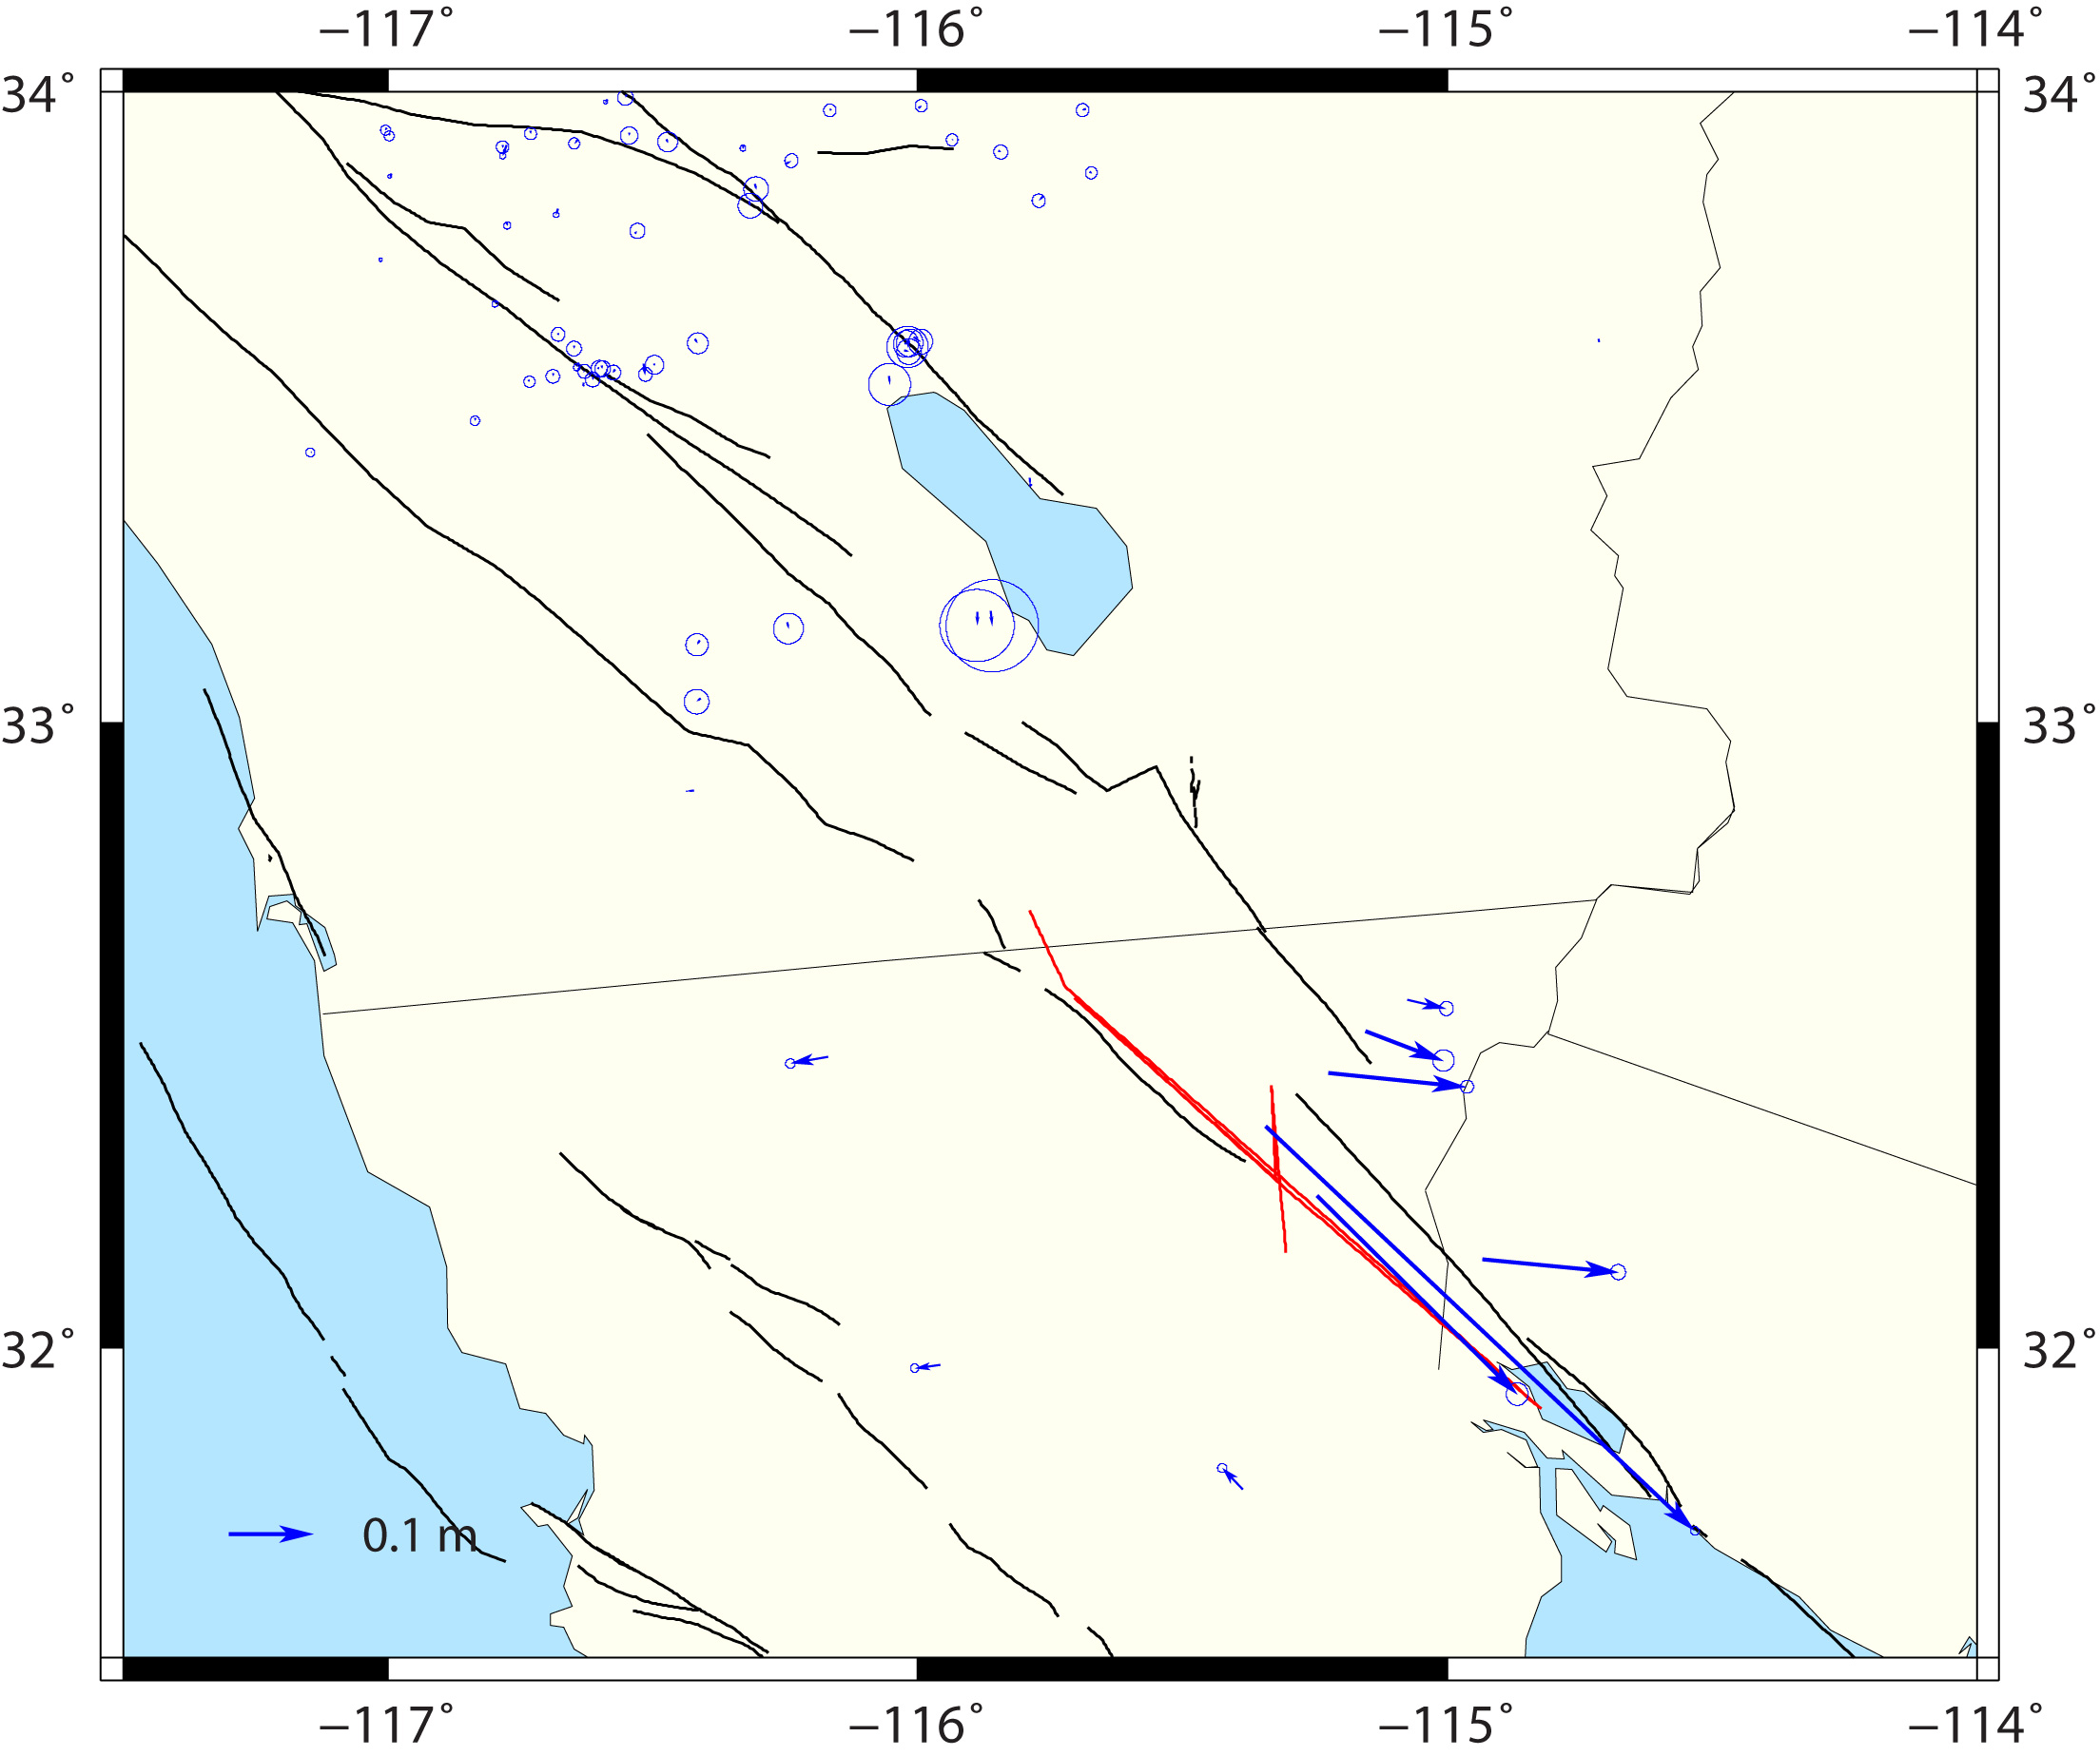
Figure 5. Coseismic displacement estimates. Upper left: 1992 Landers, upper right: 1999 Hector Mine, lower left: 1994 Northridge, lower right: 2010 El Mayor-Cucapah earthquakes, respectively. Red curves/stars show fault surface rupture traces/epicenter locations.
Table 1. Strong earthquakes and sources of their fault rupture models.
------------------------------------------------------------------------------------
1992 M6.1 Joshua Tree Bennett et al. (1995)
1992 M7.3 Landers Hudnut et al. (1994)
1994 M6.7 Northridge Hudnut et al. (1996)
1999 M7.1 Hector Mine Agnew et al. (2002)
2003 M6.5 San Simeon Rolandone et al. (2006)
2004 M6.0 Parkfield Johanson et al. (2006)
2010 M7.2 El Mayor-Cucapah Wei et al. (2011)
----------------------------------------------------------------------------------------
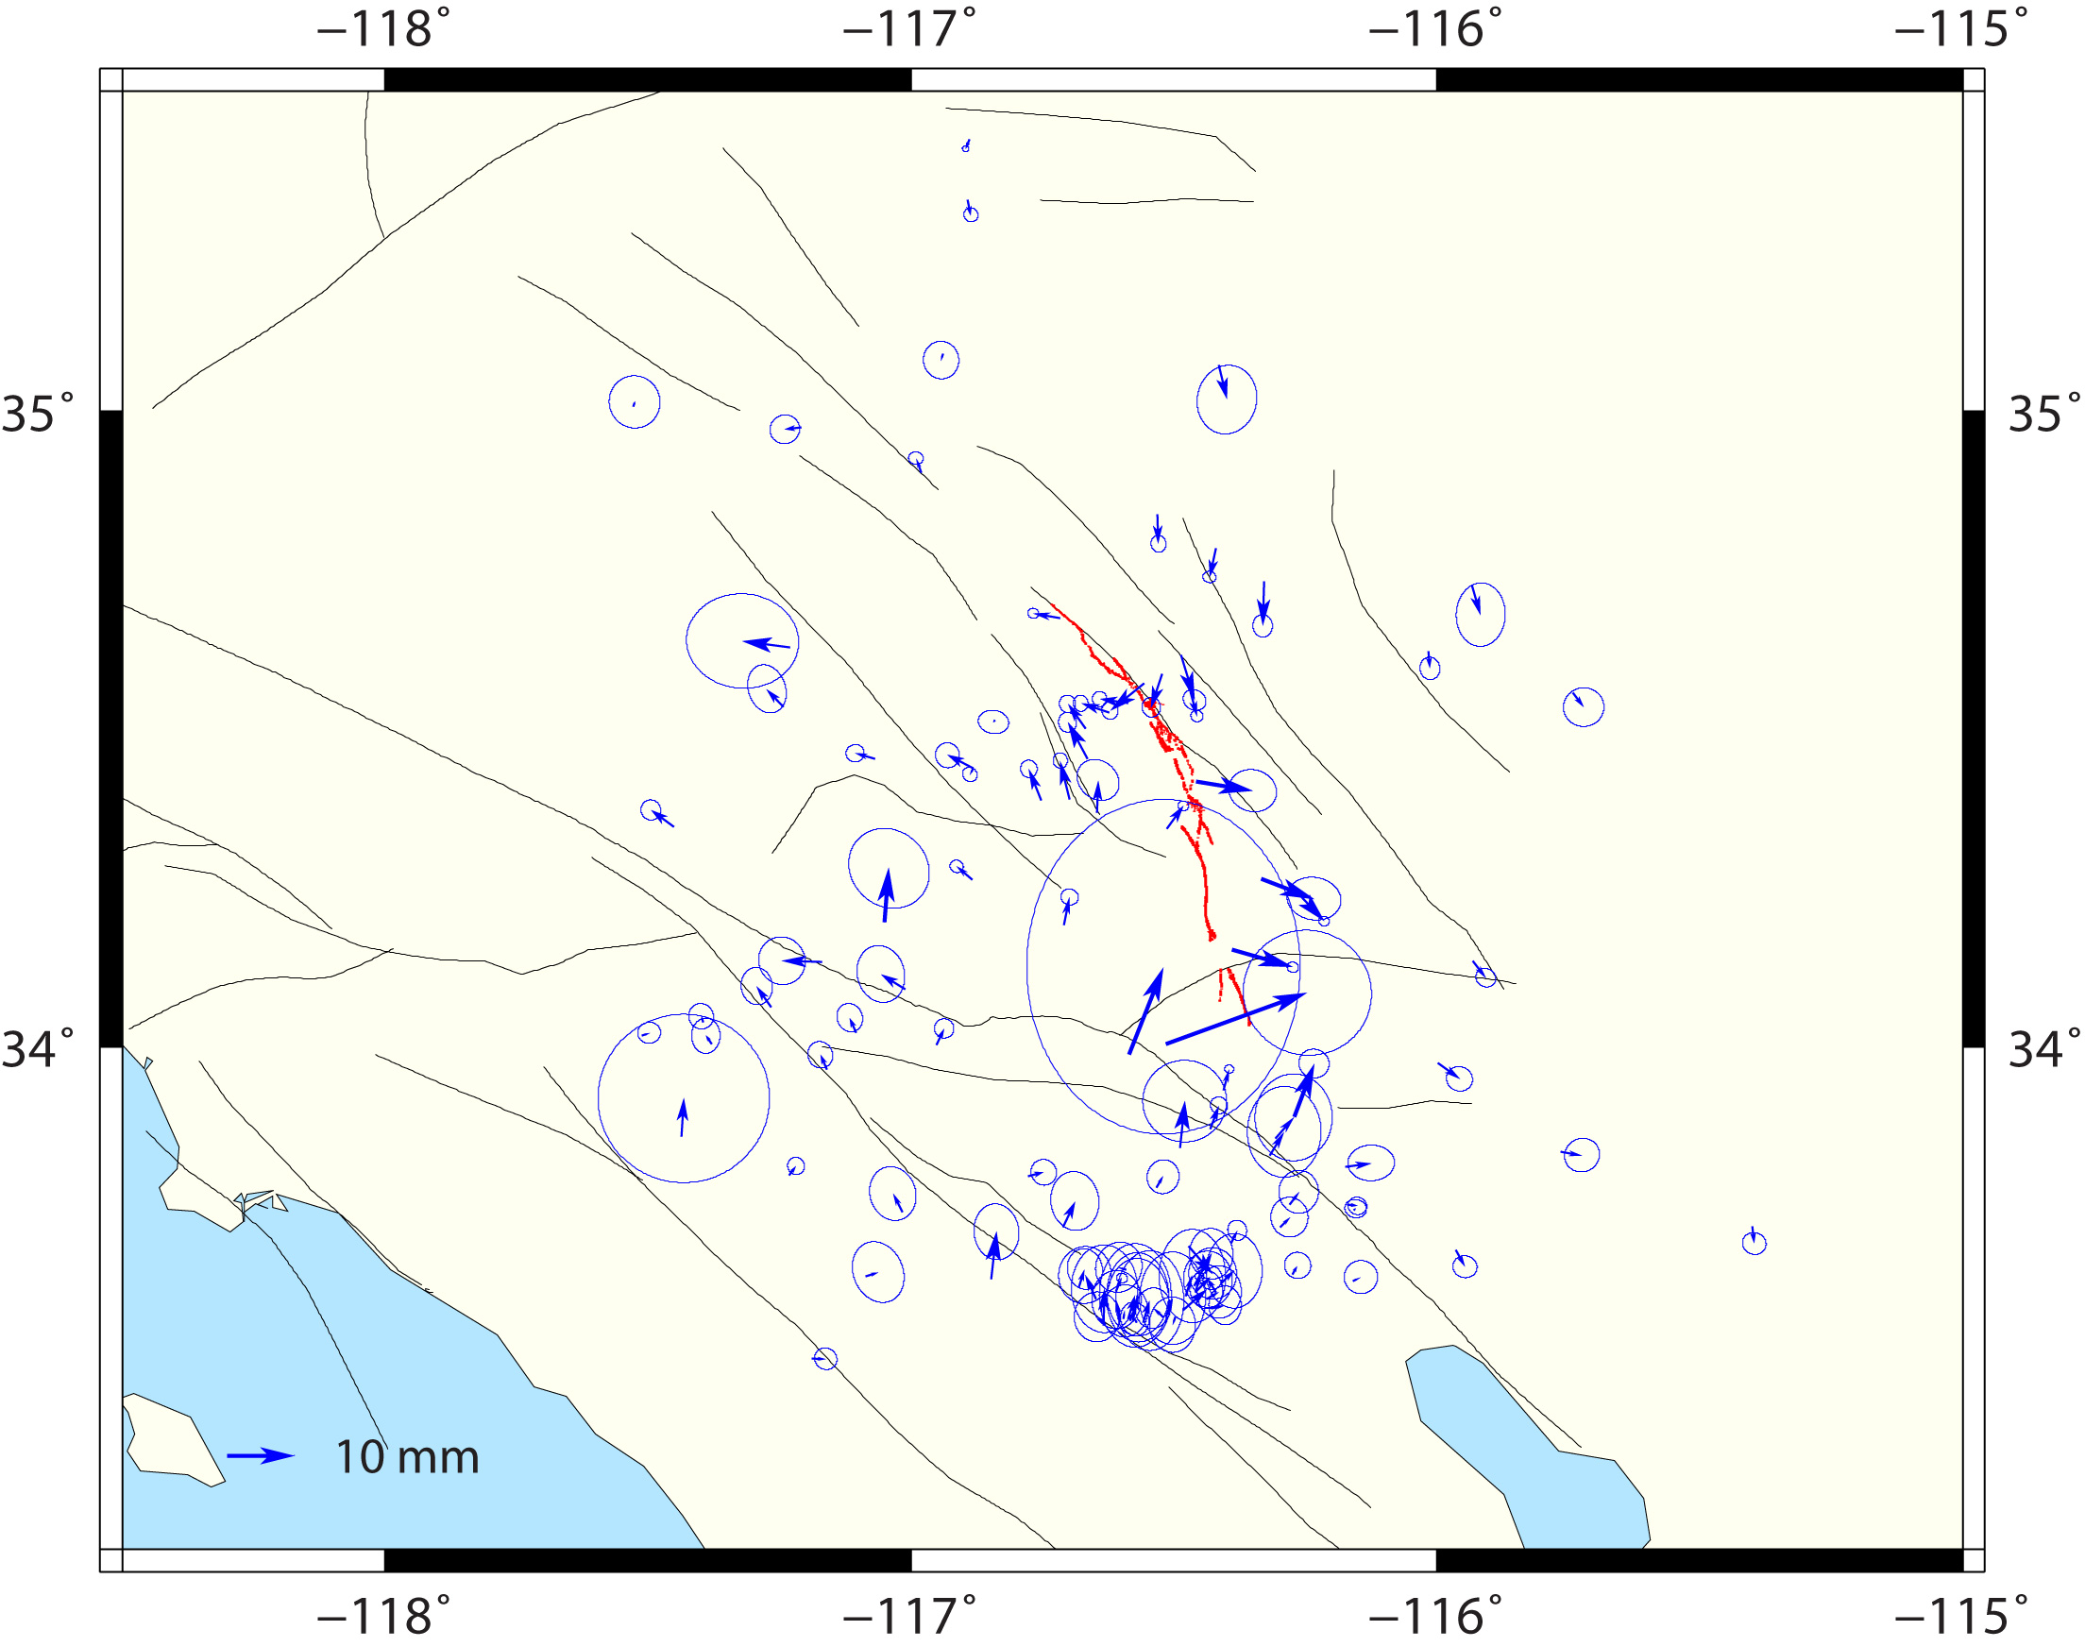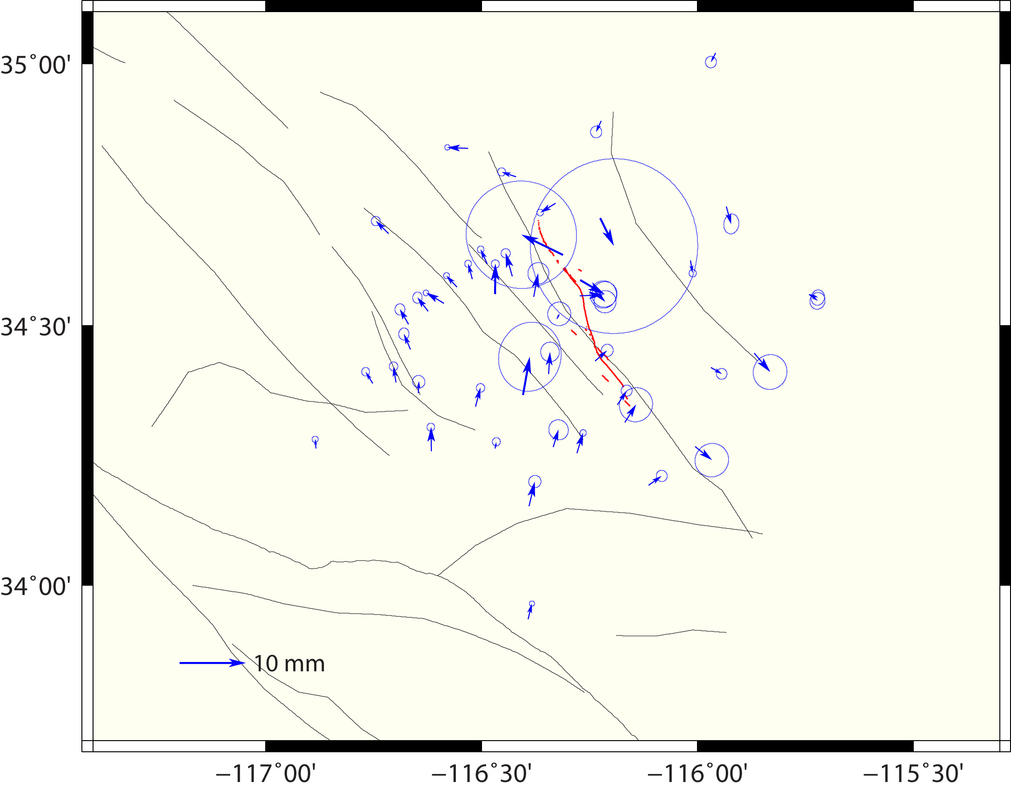
Figure 6. Postseismic displacement estimates. Upper left: 1992 Landers, upper right: 1999 Hector Mine, lower left: 1994 Northridge, lower right: 2010 El Mayor-Cucapah earthquakes, respectively. The vectors show amplitudes of horizontal components of logarithmic decay functions, with the decay time as of 10 days.
Some of the campaign sites do not have enough observations to effectively constrain their coseismic and/or postseismic displacements, and a priori information is introduced to provide the constraints. Such a priori constraints are derived from coseismic slip models of previous studies, as listed in Table 1. Coseismic displacements are forward-predicted from each of the fault slip models, and the sites with horizontal displacements exceeding 3 millimeters in amplitude are allowed to have coseismic displacements solved in the model. The model predicted coseismic displacements are used as a prioris, and their uncertainties are assumed equal to the amplitudes of the horizontal displacements. The sites whose coseismic displacements exceeding 30 millimeters are also allowed to have their postseismic displacements solved. These postseismic displacements are assumed in the logarithmic functional form, with the decay time equal to 10 days (Shen et al., 2011). The a prioris of the postseismic displacements are assumed one tenth of their model predicted coseismic displacements, with uncertainties equal to the horizontal amplitudes of the aprioris.

To accommodate temporal correlation of the GPS data errors, perturbations are assigned for site position time series in Kalman filtering model, as 1, 1, and 9 mm²/yr for the east, north, and up components, respectively. Constraints on 7 network configuration parameters were applied to tie the solutions to the Stable North America Reference Frame (SNARF) reference frame (Blewitt et al., 1995). This was done by minimizing postfit residuals of 7 configuration parameters (translation, rotation, and scale) of a network of reference sites, whose horizontal velocities and SNARF model predicted velocities are used to compute the 7 configuration parameters and their residuals.

The Kalman filter solution was run iteratively, each time inspecting the time series, fixing outliers, inserting additional offsets for data with significant jumps in data time series, and adding more coseismic and/or postseismic parameters for sites showing coseismic and/or postseismic displacements in time series. The iteration stops when all the noticeable problems are fixed.

The final velocity solution is shown in Fig. 4, which includes 806 sites located in southern California. Among the 806 sites a dozen are continuous sites, and the rest are campaign sites. The coseismic and postseismic displacements of four large earthquakes are also presented in Figs. 5 and 6 respectively.

  - Production of Station Position Time Series

Using the model parameters obtained above, we compute the postfit residual time series. A group of sites with long occupation history are chosen to provide reference for the station time series. Using the crustal motion model parameters (velocities and coseismic/postseismic displacements) of the sites, site positions are forward predicted at the data epochs, and 7 configuration parameters of the site residual positions are computed and minimized to provide the reference for the daily solutions. Advantage of producing the time series in this way is that it helps stabilize the network reference, which is important for the data of early years when the reference constraints are relatively weak.

Supplemental Materials

Numerical solutions and provided in the supplemental materials. The supplement tables are:
Table S1. GPS velocity estimates.
Table S2. Earthquake and offset epochs.
Table S3. Coseismic and offset jump estimates.
Table S4. Postseismic epochs.
Table S5. Postseismic logarithmic displacement amplitude estimates.
Table S6. GPS site position residual time series. To restore the original time series, locate the velocity (V), coseismic and offset jump (Te, D), and postseismic logarithmic displacement (Te, P, Tau) parameters from Tables S1-S5, and add the modeling term V*t+D*H(t-Te)+P*Log(1+(t-Te)/Tau) back to the residual time series.
Table S7. GPS site position time series. As described in Table S6 caption, all the modeling terms have been added back to the residual time series.

References
Agnew, D. C., Owen, S., Shen, Z. K., Anderson, G., Svarc, J., Johnson, H., & Reilinger, R. (2002). Coseismic displacements from the Hector Mine, California, earthquake: results from survey-mode global positioning system measurements. Bulletin of the Seismological Society of America, 92(4), 1355-1364.
Bennett, R. A., Reilinger, R. E., Rodi, W., & Li, Y. (1995). the Joshua Tree-Landers earthquake sequence. Journal of geophysical research, 100(B4), 6443-6461.
Herring, T. A., King, R. W., & McClusky, S. C. (2010). Introduction to Gamit/Globk. Massachusetts Institute of Technology, Cambridge, Massachusetts.
Hudnut, K. W., Bock, Y., Cline, M., Fang, P., Feng, Y., Freymueller, J., & King, N. E. (1994). Co-seismic displacements of the 1992 Landers earthquake sequence. Bulletin of the Seismological Society of America, 84(3), 625-645.
Hudnut, K. W., Shen, Z., Murray, M., McClusky, S., King, R., Herring, T.,. & Bock, Y. (1996). Co-seismic displacements of the 1994 Northridge, California, earthquake. Bulletin of the Seismological Society of America, 86(1B), S19-S36.
Johanson, I. A., Fielding, E. J., Rolandone, F., & Bürgmann, R. (2006). Coseismic and postseismic slip of the 2004 Parkfield earthquake from space-geodetic data. Bulletin of the Seismological Society of America, 96(4B), S269-S282.
Rolandone, F., Dreger, D., Murray, M., & Bürgmann, R. (2006). Coseismic slip distribution of the 2003 Mw 6.6 San Simeon earthquake, California, determined from GPS measurements and seismic waveform data. Geophysical research letters, 33(16).
Shen, Z. K., King, R. W., Agnew, D. C., Wang, M., Herring, T. A., Dong, D., & Fang, P. (2011). A unified analysis of crustal motion in Southern California, 1970–2004: The SCEC crustal motion map. Journal of Geophysical Research: Solid Earth, 116(B11).
Wei, S., Fielding, E., Leprince, S., Sladen, A., Avouac, J. P., Helmberger, D., & Herring, T. (2011). Superficial simplicity of the 2010 El Mayor-Cucapah earthquake of Baja California in Mexico. Nature Geoscience, 4(9), 615-618.

